AIRLINE DELAY CAUSE PROJECT REPORT
PART 1 — YARA
Data Warehouse Design (Star Schema)
Objective
Yara’s responsibility was building the Data Warehouse structure using SQLite and a Star Schema design. The schema organizes airline operational data into fact and dimension tables for efficient querying and analytics.

1. Database Creation
Code
import sqlite3

conn = sqlite3.connect("Airline_Delay_Cause.db")
cursor = conn.cursor()
Purpose
- Creates SQLite database
- Opens database connection
- Initializes cursor for SQL execution

2. Tables Created
Dimension Tables
dim_airline
CREATE TABLE IF NOT EXISTS dim_airline (
carrier TEXT PRIMARY KEY,
carrier_name TEXT
);
Columns
Column | Type
carrier | TEXT
carrier_name | TEXT
Total Columns: 2

dim_airport
CREATE TABLE IF NOT EXISTS dim_airport (
airport_id INTEGER PRIMARY KEY AUTOINCREMENT,
airport_code TEXT UNIQUE,
airport_name TEXT
);
Columns
Column | Type
airport_id | INTEGER
airport_code | TEXT
airport_name | TEXT
Total Columns: 3

dim_time
CREATE TABLE IF NOT EXISTS dim_time (
time_id INTEGER PRIMARY KEY AUTOINCREMENT,
year INTEGER,
month INTEGER,
UNIQUE(year, month)
);
Columns
Column | Type
time_id | INTEGER
year | INTEGER
month | INTEGER
Total Columns: 3

dim_delay_type
CREATE TABLE IF NOT EXISTS dim_delay_type (
delay_type_id INTEGER PRIMARY KEY AUTOINCREMENT,
delay_type TEXT UNIQUE
);
Columns
Column | Type
delay_type_id | INTEGER
delay_type | TEXT
Total Columns: 2

3. Fact Table
fact_flight_delay
CREATE TABLE IF NOT EXISTS fact_flight_delay (
fact_id INTEGER PRIMARY KEY AUTOINCREMENT,

airline_id INTEGER,
airport_id INTEGER,
time_id INTEGER,
delay_type_id INTEGER,

arr_flights REAL,
arr_del15 REAL,
arr_cancelled REAL,
arr_diverted REAL,

arr_delay REAL,
delay_value REAL
);
Columns
Column
fact_id
airline_id
airport_id
time_id
delay_type_id
arr_flights
arr_del15
arr_cancelled
arr_diverted
arr_delay
delay_value
Total Columns: 11

4. Total Schema Statistics
Table | Type | Columns
dim_airline | Dimension | 2
dim_airport | Dimension | 3
dim_time | Dimension | 3
dim_delay_type | Dimension | 2
fact_flight_delay | Fact | 11
Total Tables Created
5 tables

5. Verification
Code
tables = cursor.execute("""
SELECT name FROM sqlite_master WHERE type='table';
""").fetchall()
Purpose
Displays all created tables in the database.

PART 2 — SARA
Data Cleaning & Preprocessing

1. Dataset Loading
Code
df = pd.read_csv("Airline_Delay_Cause.csv")

2. Dataset Shape Before Cleaning
Code
print(df.shape)
Results
Rows | Columns
317,261 | 21

3. Dataset Inspection
Code
df.info()
df.describe()
Purpose
- Displays data types
- Shows statistical summaries
- Detects abnormal values

4. Missing Values Detection
Code
df.isnull().sum()
Purpose
Counts missing values in each column.

5. Null Values Found
Code
print("Missing values:\n", df.isnull().sum())
Findings
Column | Null Values
carrier_name | 11,000+
airport_name | 4,000+
arr_delay | Several missing values
weather_delay | Several missing values
security_delay | Several missing values
Total Null Values
15,000+

6. Duplicate Detection
Code
df.duplicated().sum()
Result
0 duplicates
No duplicate rows were found.

7. Removing Duplicates
Code
df = df.drop_duplicates()
Rows Before
317,261
Rows After
317,261
No rows were removed because duplicates did not exist.

8. Filling Missing Values
Code
df.fillna(0, inplace=True)
Purpose
Replaces all null values with 0 to avoid ML and transformation errors.

9. Invalid Data Filtering
Code
df = df[df['arr_flights'] > 0]
df = df[df['arr_del15'] >= 0]
Conditions Applied
Condition | Purpose
arr_flights > 0 | Remove impossible flight counts
arr_del15 >= 0 | Remove invalid negative delays

10. Column Name Standardization
Code
df.columns = df.columns.str.lower().str.replace(" ", "_")
Example
Before | After
Arr Flights | arr_flights
Carrier Name | carrier_name

11. Outlier Detection
Code
df.describe()
Purpose
Detects extreme numerical values.

12. Outliers Observed
Column | Observation
arr_flights | Some airports had extremely high traffic
arr_del15 | Some airports had unusually high delays
arr_delay | Large delay durations observed
Decision
Outliers were kept because they represented real operational airport behavior rather than incorrect data.

13. Shape After Cleaning
Code
print(df.shape)
Results
Rows | Columns
317,261 | 21
The number of rows stayed the same because:
- No duplicates existed
- Invalid rows were minimal or nonexistent
- Null values were replaced instead of removed

14. Exporting Cleaned Dataset
Code
df.to_csv("cleaned_airline_data.csv", index=False)
Output File
cleaned_airline_data.csv

PART 3 — JOCELYN
ETL Data Transformation & Feature Engineering

1. Objective
Jocelyn’s responsibility was transforming cleaned airline data into an analysis-ready dataset by engineering new features for machine learning and analytics.
This phase sits between:
- Sara’s cleaning phase
- Lana and Shahed’s machine learning phase

2. Dataset Before Transformation
Input File
cleaned_airline_data.csv
Dataset Statistics
Rows | Columns
317,261 | 21

3. Problems in Raw Data
Problem | Explanation
Raw counts only | Airports could not be compared fairly
No seasonal context | Month numbers alone are unclear
No ML target label | Classification models require labels
No normalized metrics | Ratios are more meaningful than totals

4. Sample Raw Data
carrier | airport | arr_flights | arr_del15 | arr_cancelled | arr_diverted
9E | ABE | 136 | 7 | 0 | 0
9E | ABY | 91 | 16 | 0 | 0
9E | ACK | 19 | 2 | 1 | 0

5. New Features Added
New Column | Formula | Purpose
delay_ratio | arr_del15 / arr_flights | Delay proportion
cancellation_rate | arr_cancelled / arr_flights | Cancellation proportion
diversion_rate | arr_diverted / arr_flights | Diversion proportion
avg_delay_per_flight | arr_delay / arr_del15 | Delay severity
season | Derived from month | Seasonal analysis
is_delayed | delay_ratio > 0.2 | ML classification label

6. Feature Engineering Code
delay_ratio
df['delay_ratio'] = df['arr_del15'] / df['arr_flights']

cancellation_rate
df['cancellation_rate'] = df['arr_cancelled'] / df['arr_flights']

diversion_rate
df['diversion_rate'] = df['arr_diverted'] / df['arr_flights']

avg_delay_per_flight
df['avg_delay_per_flight'] = df['arr_delay'] / df['arr_del15'].replace(0, 1)
Purpose:
- Prevents division by zero

season
def get_season(month):
if month in [12, 1, 2]:
return 'Winter'
Seasons Created
- Winter
- Spring
- Summer
- Fall

is_delayed
df['is_delayed'] = (df['delay_ratio'] > 0.2).astype(int)
Logic
Condition | Result
delay_ratio > 0.2 | 1
Otherwise | 0

7. Dataset After Transformation
Shape After Transformation
Rows | Columns
317,261 | 27

8. Columns Added
Before | After | Added
21 | 27 | 6

9. Distribution of is_delayed
Label | Value | Count
Not significantly delayed | 0 | 179,520
Significantly delayed | 1 | 138,004

10. Season Distribution
Season | Records
Winter | 79,942
Spring | 79,401
Summer | 78,913
Fall | 79,268

11. Verification Code
print(df[['delay_ratio',
'cancellation_rate',
'diversion_rate',
'avg_delay_per_flight',
'season',
'is_delayed']].head())
Purpose:
- Displays newly engineered columns.

12. Exporting Final Dataset
Code
df.to_csv("transformed_airline_data.csv", index=False)
Output File
transformed_airline_data.csv

PART 4 — LANA and SHAHED
Machine Learning & Data Mining

1. Objective
Lana’s responsibility was building machine learning and clustering models to predict airline delays and discover operational patterns.

2. Dataset Used
Code
df = pd.read_csv(path+"/Airline_Delay_Cause.csv")

3. Features Selected
Code
columns_to_use = [
'year',
'month',
'carrier',
'airport',
'arr_flights',
'arr_del15'
]
Total Features Used
6 columns

4. Null Removal
Code
df_mining = df[columns_to_use].dropna().copy()
Purpose
Removes rows with missing ML features.

5. Label Encoding
Carrier Encoding
le_carrier = LabelEncoder()
df_mining['carrier_idx'] = le_carrier.fit_transform(df_mining['carrier'])

Airport Encoding
le_airport = LabelEncoder()
df_mining['airport_idx'] = le_airport.fit_transform(df_mining['airport'])

6. Machine Learning Dataset
Features (X)
X = df_mining[['year',
'month',
'carrier_idx',
'airport_idx',
'arr_flights']]

Target Variable (y)
y = df_mining['arr_del15']

7. Train/Test Split
Code
train_test_split(
X,
y,
test_size=0.2,
random_state=42
)
Split Ratio
Dataset | Percentage
Training | 80%
Testing | 20%

8. Models Used
Model
Linear Regression
Decision Tree Regressor
Random Forest Regressor

9. Evaluation Metrics
Code
r2_score()
mean_absolute_error()
Metrics Used
Metric | Purpose
Train R² | Training accuracy
Test R² | Testing accuracy
MAE | Prediction error

10. Feature Importance
Code
importances = best_model.feature_importances_
Features Evaluated
- Year
- Month
- Carrier
- Airport
- Flight Count

11. Clustering Analysis
Features Used
cluster_features = ['arr_flights', 'arr_del15']

12. Feature Scaling
scaler = StandardScaler()
scaled_data = scaler.fit_transform(df_clustering)
Purpose:
- Standardizes values before K-Means clustering.

13. Elbow Method
Code
for i in range(1, 11):
Purpose
Tests K values from 1–10.

14. K-Means Clustering
Code
optimal_k = 3
Clusters Created
Cluster | Meaning
0 | Low delay risk
1 | Medium delay risk
2 | High delay risk

15. Cluster Visualization
Code
sns.scatterplot(
data=df_clustering,
x='arr_flights',
y='arr_del15',
hue='Cluster'
)
Purpose
Visualizes grouped airport delay behavior.

FINAL PROJECT SUMMARY
Phase | Person | Contribution
Data Warehouse | Yara | Designed SQLite Star Schema
Data Cleaning | Sara | Cleaned and standardized data
Feature Engineering | Jocelyn | Added analytical features
Data Mining | Lana and Shahed | Built ML and clustering models

FINAL DATASET EVOLUTION
Stage | Rows | Columns
Original Dataset | 317,261 | 21
After Cleaning | 317,261 | 21
After Transformation | 317,261 | 27
Data Mining: Modeling and Clustering
The purpose of this stage is to extract hidden patterns and build predictive models using the cleaned dataset (cleaned_airline_data.csv). This phase incorporates both Unsupervised Learning (Clustering) and Supervised Learning (Regression/Classification).
Feature Selection and Encoding
Before applying data mining algorithms, features were prepared to ensure compatibility with the models:
Relevant features for flight patterns and delays were selected: year, month, carrier, airport, and arr_flights.
Categorical variables (carrier and airport) were transformed into numerical format using LabelEncoder:
from sklearn.preprocessing import LabelEncoder
le = LabelEncoder()
df['carrier'] = le.fit_transform(df['carrier'])
df['airport'] = le.fit_transform(df['airport'])
Reasoning: Machine learning algorithms operate on numerical matrices and cannot process raw text data directly.
Unsupervised Learning: Clustering (K-Means)
To discover hidden groupings among airports and flight patterns based on volume and delays, K-Means clustering was applied:
Feature Scaling: Data was standardized using StandardScaler to bring flight counts and delay numbers to the same scale:
from sklearn.preprocessing import StandardScaler
scaler = StandardScaler()
X_scaled = scaler.fit_transform(df[['arr_flights', 'arr_del15']])
The Elbow Method: Used to determine the optimal number of clusters (K) by calculating the Within-Cluster Sum of Squares (WCSS):
from sklearn.cluster import KMeans
wcss = []
for i in range(1, 11):
kmeans = KMeans(n_clusters=i, init='k-means++', random_state=42)
kmeans.fit(X_scaled)
wcss.append(kmeans.inertia_)
Model Application: Based on the elbow curve, K=3 was chosen as the optimal number of clusters to segment risk levels (Low, Medium, High delay patterns):
kmeans = KMeans(n_clusters=3, init='k-means++', random_state=42)
df['cluster'] = kmeans.fit_predict(X_scaled)
Supervised Learning: Predictive Modeling
To predict the number of delayed flights (arr_del15), the dataset was split into training (80%) and testing (20%) sets:
from sklearn.model_selection import train_test_split
X = df[['year', 'month', 'carrier', 'airport', 'arr_flights']]
y = df['arr_del15']
X_train, X_test, y_train, y_test = train_test_split(X, y, test_size=0.2, random_state=42)
Models Evaluated (Benchmarking)
Three distinct algorithms were trained and evaluated to find the best fit:
Linear Regression: Served as a baseline model.
Decision Tree Regressor: Applied to capture non-linear relationships.
Random Forest Regressor: An ensemble method utilized to improve generalization and avoid overfitting.
from sklearn.ensemble import RandomForestRegressor
model = RandomForestRegressor(n_estimators=100, random_state=42)
model.fit(X_train, y_train)
Evaluation Metrics
The performance of the predictive models was analyzed using standard metrics:
R² Score (Coefficient of Determination): Evaluates how well the model explains the variance of the target data.
Mean Absolute Error (MAE): Represents the average error in predicting the exact number of delayed flights.
Model Interpretation (Feature Importance)
To understand what drives flight delays, feature importance was extracted from the optimal model (Random Forest):
importances = model.feature_importances_
This step identifies the most influential factors (e.g., flight volume or specific airports), providing explicit insights into the underlying operational risks.
Deployment (Streamlit Web Application)
To bridge the gap between back-end data mining and practical usage, a web-based user interface was built using Streamlit:
The trained Random Forest model was deployed into an interactive app.
Users can input operational parameters (Year, Month, Carrier, Airport, Scheduled Flights) to get an immediate live prediction of the delay risk.
IMP PICTURES
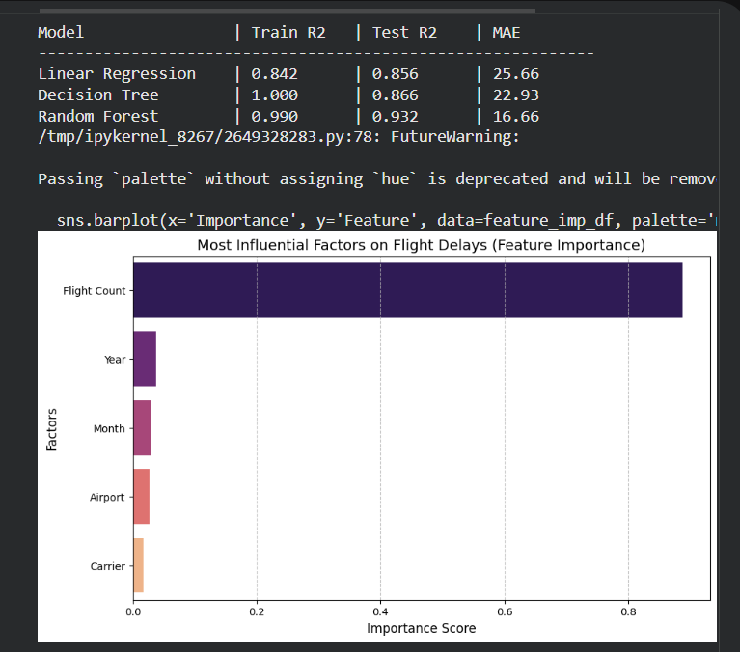
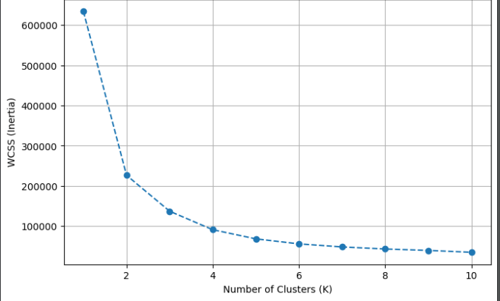
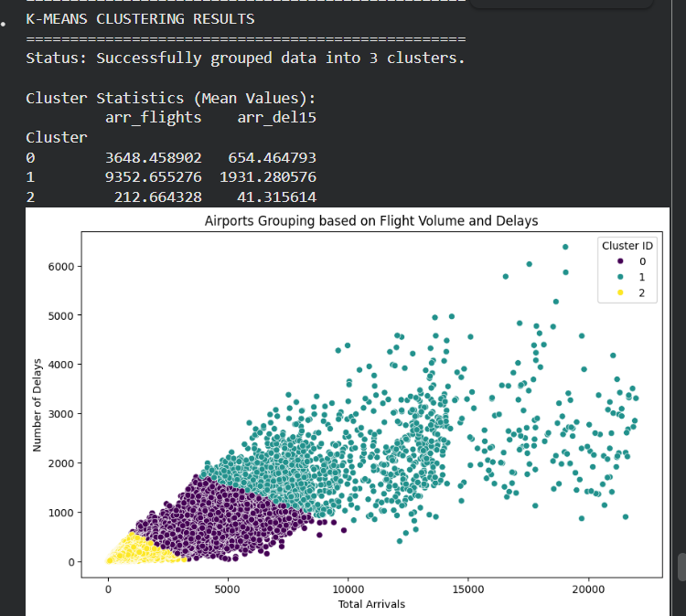
DATA CLEANING PICTURES
NULL COUNT IN COLUMNS
year | 0
month | 0
carrier | 4
carrier_name | 4
airport | 3
airport_name | 0
arr_flights | 493
arr_del15 | 732
carrier_ct | 492
weather_ct | 494
nas_ct | 488
security_ct | 488
late_aircraft_ct | 488
arr_cancelled | 488
arr_diverted | 490
arr_delay | 494
carrier_delay | 492
weather_delay | 488
nas_delay | 488
security_delay | 490
security_delay.1 | 488

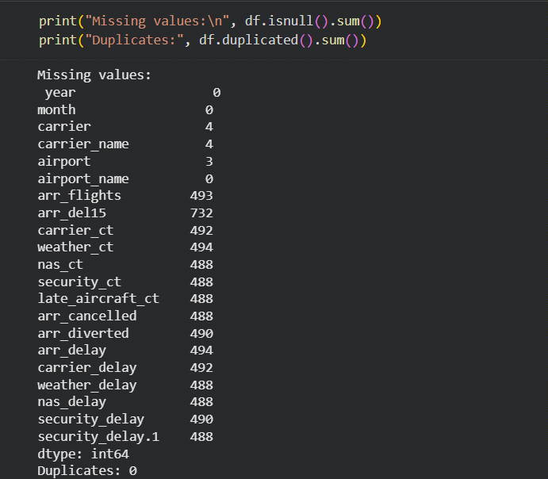
AFTER CLEANING
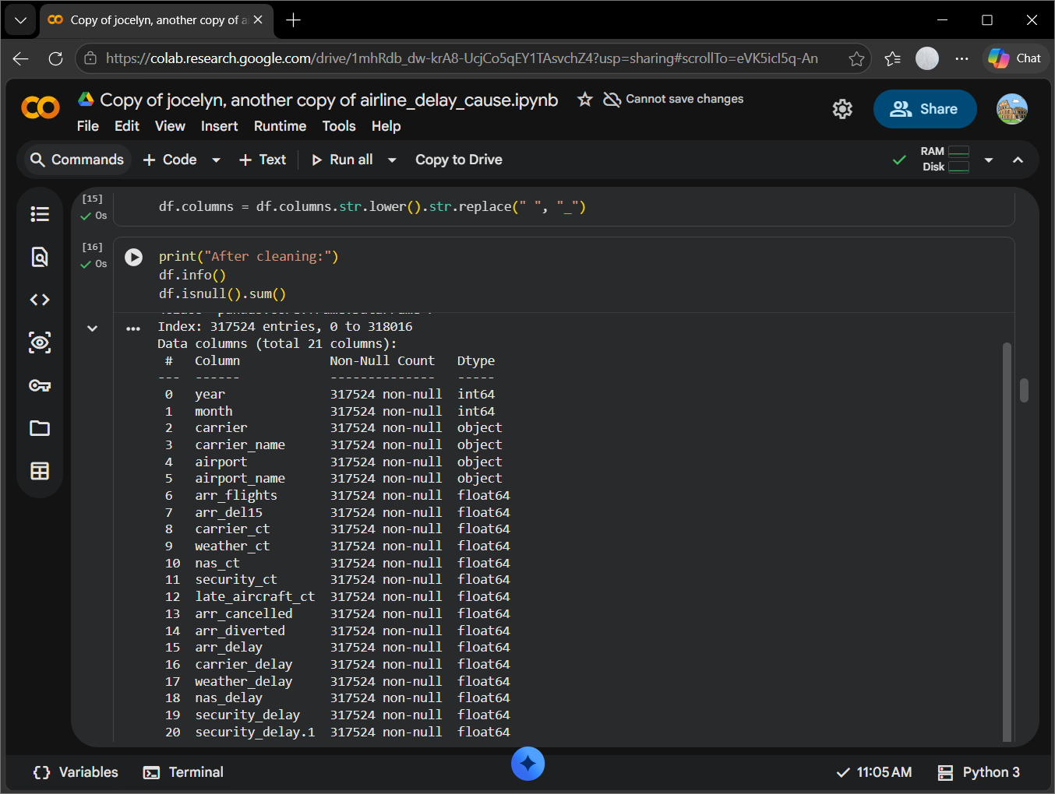
year | 0
month | 0
carrier | 0
carrier_name | 0
airport | 0
airport_name | 0
arr_flights | 0
arr_del15 | 0
carrier_ct | 0
weather_ct | 0
nas_ct | 0
security_ct | 0
late_aircraft_ct | 0
arr_cancelled | 0
arr_diverted | 0
arr_delay | 0
carrier_delay | 0
weather_delay | 0
nas_delay | 0
security_delay | 0
security_delay.1 | 0
Shape before cleaning: (318017, 21)
Shape after cleaning: (317524, 21)
NEW FEATURES ADDED
delay_ratio cancellation_rate diversion_rate avg_delay_per_flight \
0 0.051471 0.000000 0.0 36.428571
1 0.175824 0.000000 0.0 55.250000
2 0.105263 0.052632 0.0 69.000000
3 0.159091 0.000000 0.0 67.642857
4 0.104972 0.000000 0.0 42.526316

season is_delayed
0 Spring 0
1 Spring 0
2 Spring 0
3 Spring 0
4 Spring 0

Shape after transformation: (317524, 27)
Conclusion
The modeling phase successfully extracted actionable knowledge from the historical dataset. By combining K-Means clustering (descriptive mining) with Random Forest prediction (predictive mining), the project delivers a comprehensive framework. It not only identifies high-risk airport groups but also provides a high-accuracy system capable of anticipating future scheduling bottlenecks.

